LAB NO. 1

Introduction to Operating System (OS)
An Operating System (OS) is software that manages computer hardware and software resources. It acts as an interface between the user and the computer hardware, ensuring smooth functioning.

Functions of an OS:
- Process Management – Manages running programs.
- Memory Management – Allocates and deallocates memory.
- File System Management – Organizes and stores files.
- Device Management – Controls hardware like printers and keyboards.
- Security & Access Control – Protects data from unauthorized access.
- User Interface – Provides a way for users to interact (CLI/GUI).

Examples of Operating Systems:
- Windows – Used in most personal computers.
- Linux – Open-source and used for servers.
- MacOS – Designed for Apple computers.
- Android – Mobile OS developed by Google.
- iOS – Mobile OS for Apple devices.
- Unix – Used for servers and workstations.

Why Do We Use an Operating System (OS)?
An Operating System (OS) is essential because it manages the computer’s hardware and software, making it easy for users to operate the system efficiently. Without an OS, using a computer would be extremely difficult.

Key Reasons for Using an OS:
- User-Friendly Interface
Provides a Graphical User Interface (GUI) or Command-Line Interface (CLI) for easy interaction.
- Hardware Management
Controls and coordinates hardware components like CPU, memory, hard drives, and printers.
- Software Management
Helps install, run, and manage multiple applications (e.g., MS Word, Chrome, Games).
- Multi-Tasking
Runs multiple applications simultaneously (e.g., browsing while listening to music).
- Memory Management
Allocates and deallocates memory for efficient performance.
- File and Data Management
Organizes, stores, retrieves, and secures files and folders.
- Security and Protection
Prevents unauthorized access through passwords, encryption, and firewalls.
- Networking
Supports internet and network connections for communication and data sharing.
- Error Handling
Detects and handles errors, preventing system crashes.

Advantages of an Operating System (OS)
An Operating System (OS) makes computers easier to use by managing hardware and software efficiently. Here are its key advantages:

User-Friendly Interface
- Provides a Graphical User Interface (GUI) or Command-Line Interface (CLI) for easy interaction.
- Allows users to run programs without knowing complex coding.

Multitasking
- Runs multiple applications at the same time (e.g., browsing the web while listening to music).
- Efficiently manages CPU time for different tasks.

Resource Management
- Allocates CPU, memory, and storage efficiently.
- Ensures fair resource distribution among multiple programs.

Security and Protection
- Protects data with passwords, firewalls, and encryption.
- Prevents unauthorized access and malware attacks.

File and Data Management
- Helps organize and retrieve files easily.
- Provides features like copy, delete, move, and rename.

Hardware Management
- Controls devices like printers, keyboards, and storage drives.
- Provides drivers to communicate between software and hardware.

Error Handling
- Detects system errors and provides solutions (e.g., alerts and troubleshooting options).
- Prevents crashes and improves system stability.

Networking Support
- Enables internet and LAN (Local Area Network) connections.
- Helps share files and resources over a network.

Better Performance
- Optimizes system performance by managing tasks efficiently.
- Prevents system slowdowns by handling memory and processes properly.

Software Support
- Allows installation and execution of different applications (e.g., MS Office, games, browsers).
- Provides updates and compatibility for various programs.

What is CMD?
CMD (Command Prompt) is a command-line interpreter in Windows operating systems. It allows users to execute commands to perform tasks like navigating files, managing directories, and troubleshooting system issues.

Key Features of CMD:
- Text-Based Interface – Uses text commands instead of a graphical interface.
- File & Directory Management – Allows creating, deleting, and navigating folders.
- System Control – Can modify system settings and configurations.
- Network Troubleshooting – Helps check connectivity and IP configuration.
- Automation – Supports batch scripting to automate repetitive tasks.

Common CMD Commands:

How to Open CMD?
- Press Win + R, type cmd, and press Enter.
- Search "Command Prompt" in the Start Menu.
- Use Shift + Right Click in a folder and select "Open Command Window Here" (older versions).

Why Do We Use CMD (Command Prompt)?
CMD (Command Prompt) is used to execute commands directly in Windows without using a graphical interface. It provides more control, flexibility, and speed for various tasks.

Key Reasons for Using CMD:

1. Faster Execution
- Many tasks (e.g., file management, network checks) are quicker with commands than using a mouse.
- Example: del filename.txt deletes a file instantly.

2. System Control & Troubleshooting
- Helps diagnose and fix system issues (e.g., checking disk errors, resetting network settings).
- Example: chkdsk scans and repairs disk errors.

3. File and Folder Management
- Create, rename, move, or delete multiple files and folders quickly.
- Example: mkdir NewFolder creates a new folder.

4. Network Configuration and Testing
- Checks internet and network issues.
- Example: ping google.com tests internet connection.

5. Batch Scripting & Automation
- CMD can execute batch scripts (.bat files) to automate repetitive tasks.
- Example: A script to back up important files daily.

6. Accessing Hidden System Tools
- Some system functions are only available through CMD.
- Example: netstat shows active network connections.

7. Managing Software and Processes
- Install, uninstall, and manage software easily.
- Example: tasklist shows all running processes.

8. Security & Administrative Tasks
- Used by IT professionals to manage user permissions and security settings.
- Example: net user username /add creates a new user account.

Basic CMD commands:

Check the Files and Folders in a Directory
Command:
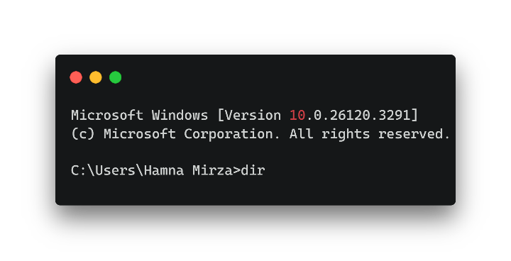
Execution:
- dir (Windows) or ls (Linux/macOS) lists all files and folders in the current directory.
If you want more details:
- Windows: dir /a (shows hidden files as well)
- Linux/macOS: ls -la (shows hidden files and detailed info)
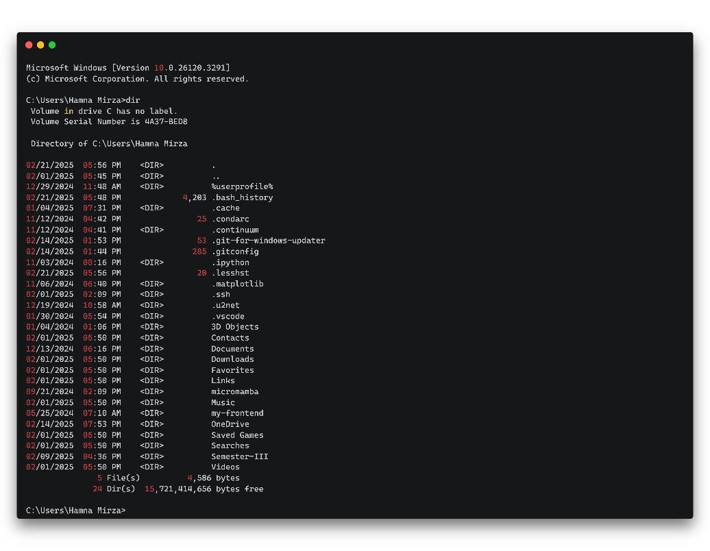
________________________________________

Create a New Folder
Command:
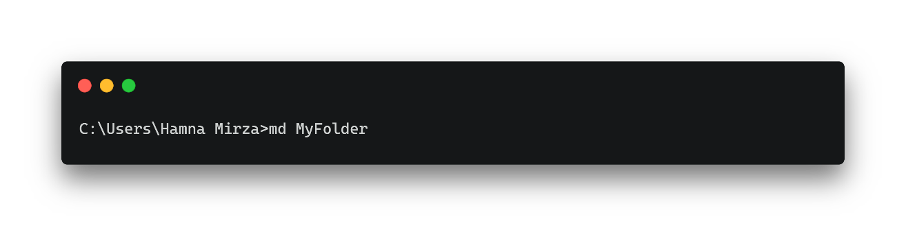
Execution:
- This command creates a new folder named MyFolder in the current directory.
- If the folder already exists, it will show an error (unless used with flags to avoid it).
- To create multiple folders at once:
- Windows: mkdir Folder1 Folder2 Folder3
- Linux/macOS: mkdir Folder1 Folder2 Folder3
________________________________________

Change Directory (Navigate to Another Folder)
Command:
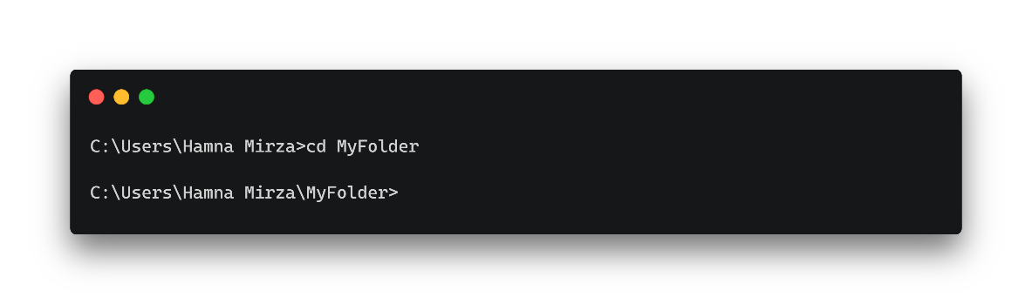
Execution:
- This command moves into the MyFolder directory from the current directory.
- If MyFolder doesn’t exist, an error will be displayed.
- To move back to the previous directory:
- Windows/Linux/macOS: cd ..
- To go to the root directory:
- Windows: cd \
- Linux/macOS: cd /
- To go directly to a specific path:
- Windows: cd C:\Users\YourName\Documents
- Linux/macOS: cd /home/yourname/Documents
________________________________________

Move Back to the Previous Directory
Command:
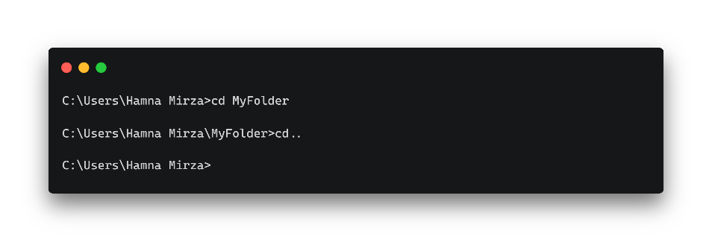
Execution:
- This command moves up one level in the folder structure.
- If you're inside C:\Users\YourName\Documents\MyFolder, running cd .. will take you to C:\Users\YourName\Documents.
- You can move multiple levels up by using cd ../.. (moves up two levels).
- To return to the last directory you were in:
- Windows: No direct command.
- Linux/macOS: cd - (switches to the last used directory).
________________________________________

Create a New Text File
Command:
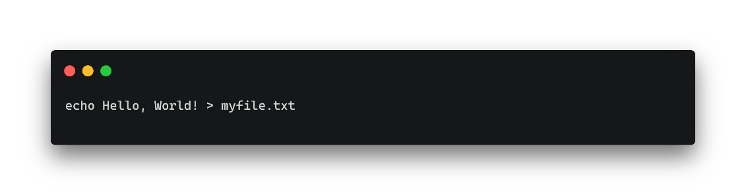
Execution:
- This command creates a new file named myfile.txt in the current directory and writes "Hello, World!" inside it.
- If myfile.txt already exists, its content will be replaced.
- To append text without replacing existing content:
- Windows: echo New Line >> myfile.txt
- Linux/macOS: echo "New Line" >> myfile.txt
________________________________________

Check Your IP Address
Command:
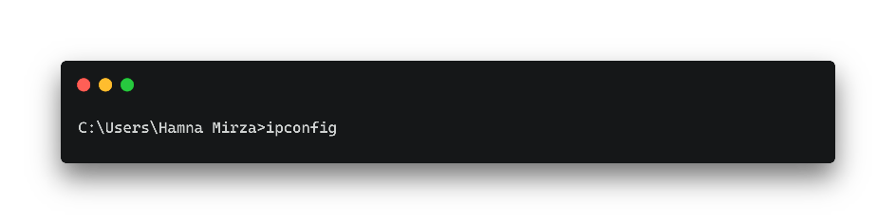
Execution:
- Displays your IP address, subnet mask, and default gateway.
- Useful for network troubleshooting and checking network configurations.
- If connected to a Wi-Fi network, look for the Wireless LAN adapter section (Windows) or wlan0 (Linux/macOS).
- If using an Ethernet connection, look for Ethernet adapter (Windows) or eth0 (Linux/macOS).
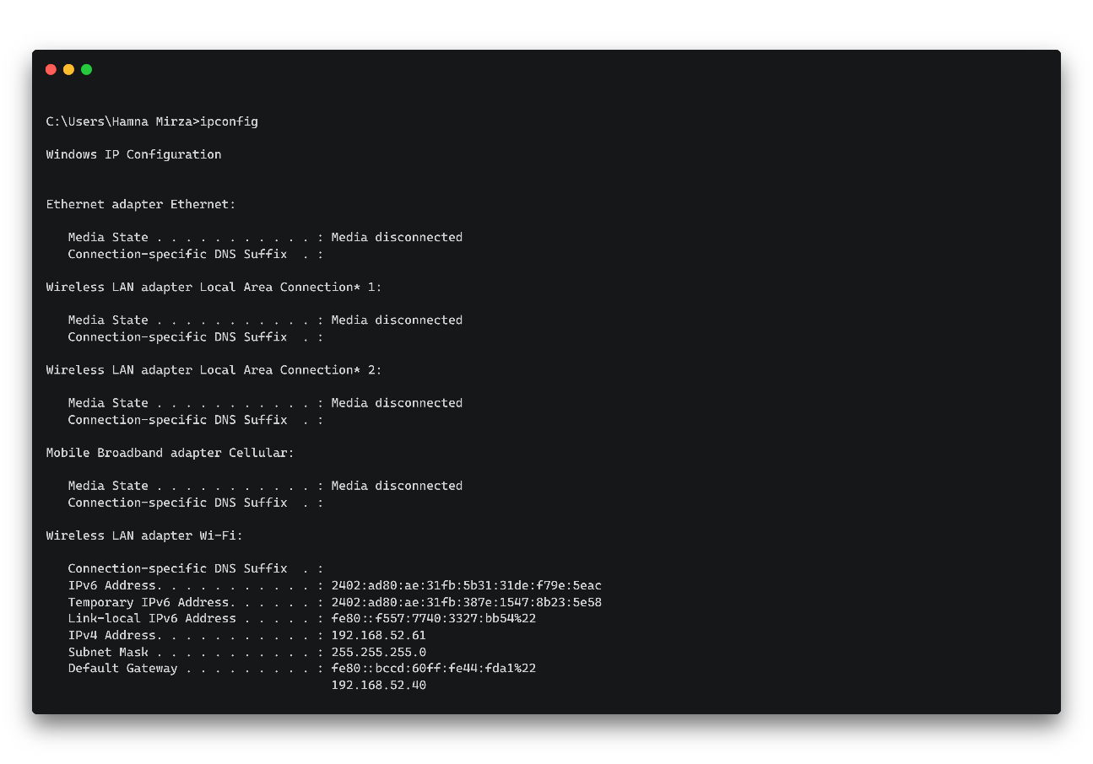
________________________________________

Clear the Command Prompt Screen
Command:
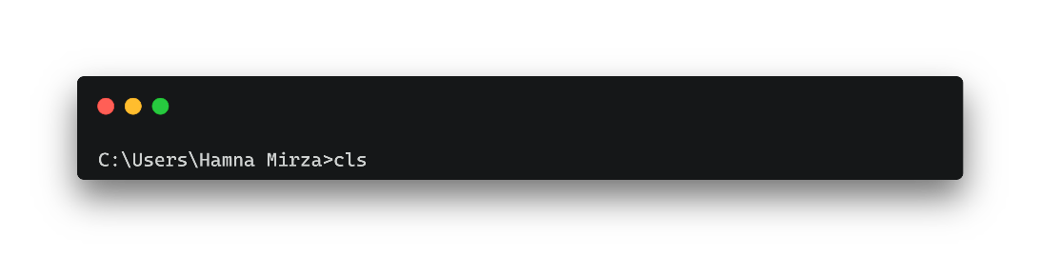
Execution:
- This command clears all text from the screen, making it easier to read new commands and output.
- The previous commands are not deleted; they can still be viewed using the scroll bar.
- Works in Command Prompt (cmd), PowerShell (Windows), and Terminal (Linux/macOS).
________________________________________

Exit the Command Prompt
Command:
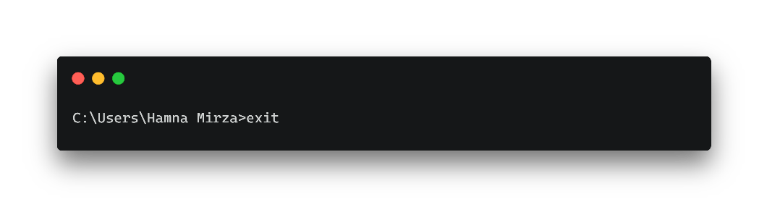
Execution:
- This command closes the Command Prompt or Terminal window immediately.
- If running inside a script, the script will terminate as well.
- On Linux/macOS, pressing Ctrl + D also closes the terminal session.

LAB NO. 2

Implementation of Basic CMD commands

CMD Prompt:
CMD (Command Prompt) is a command-line interpreter in Windows operating systems. It allows users to execute commands to perform tasks like navigating files, managing directories, and troubleshooting system issues.

Basic cmd commands:
- Cd: creating folder command
- Md: name the folder command
- Ren: renaming command
- Rd: deleting command

Create folder:
Creating folder in desktop
Run CMD as Administrator
- Close your current Command Prompt.
- Open CMD as Administrator:
  - Press Win + S, type cmd, then right-click "Command Prompt" and choose "Run as administrator".
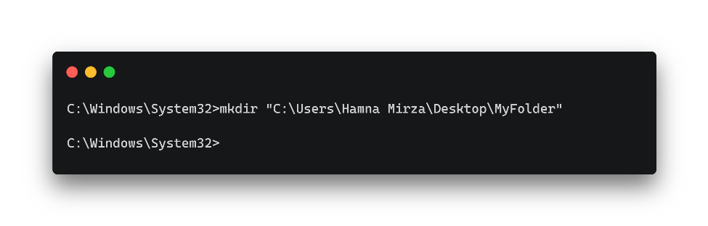
Execution:
- Fix for "Access is denied" error:
- Open Command Prompt as Administrator (Search cmd, right-click, and select Run as Administrator).
- Use double quotes (" ") if the username contains spaces (e.g., Hamna Mirza).
- This command creates a folder named MyFolder on the Desktop.
- Works for any user without needing to manually type the desktop path.

Naming folder:
Name the folder that is recently created
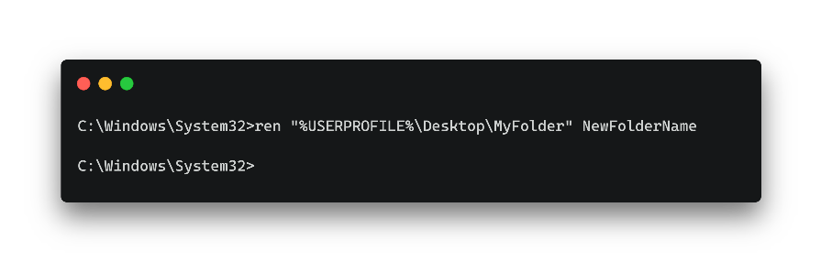
Execution:
- Windows: Renames the folder MyFolder on the Desktop to NewFolderName.
- Linux/macOS: Moves (renames) MyFolder to NewFolderName on the Desktop.
- Use double quotes (" ") if the folder name contains spaces.
  - Example: ren "C:\Users\Hamna Mirza\Desktop\My Folder" "New Folder"

Rename the folder:
If you wanted to change the name of folder.
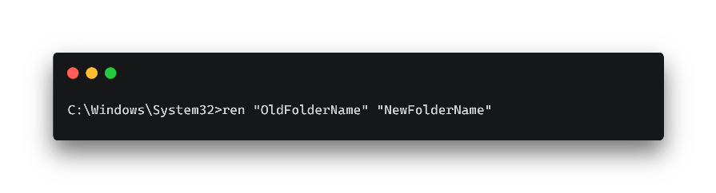
Execution:
- Windows: Renames OldFolderName to NewFolderName in the current directory.
- Linux/macOS: Moves (renames) the folder to a new name.
- Use double quotes (" ") if the folder name contains spaces.
  - Example: ren "My Old Folder" "New Folder"

Delete the folder:
If you wanted to delete the folder.

Delete the folder:
If you wanted to create multiple folders.

What if !?
If we put space between folder names.

lab no. 3

Making a Folder for Books
- We are making a folder for books with Books being main folder
- There are 3 folders in Books named Math’s, Computer and Physics
- Computer Folder has 2 subfolders Trigonometry and Calculus
- Math’s Folder has 3 subfolders Quantum, Classical and Nuclear
Code:
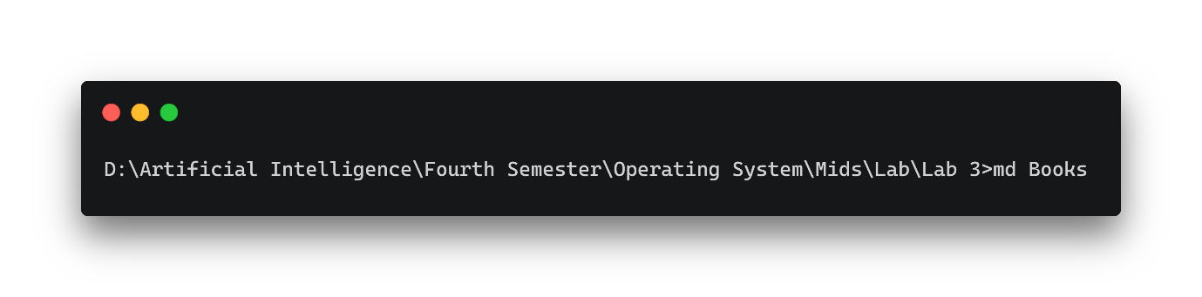Execution:
Code:
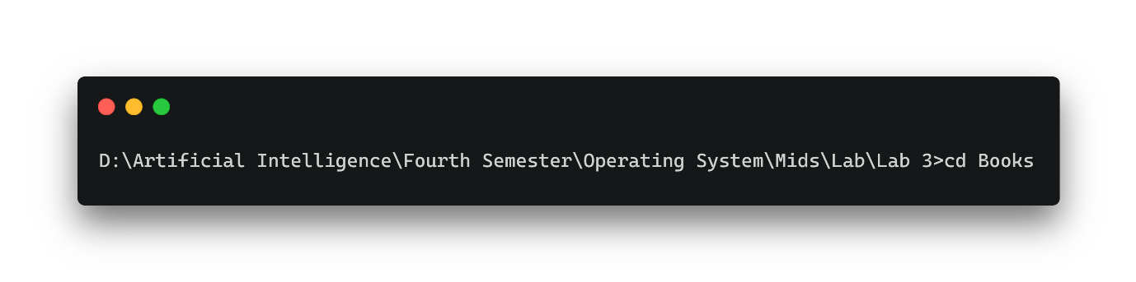
Code:
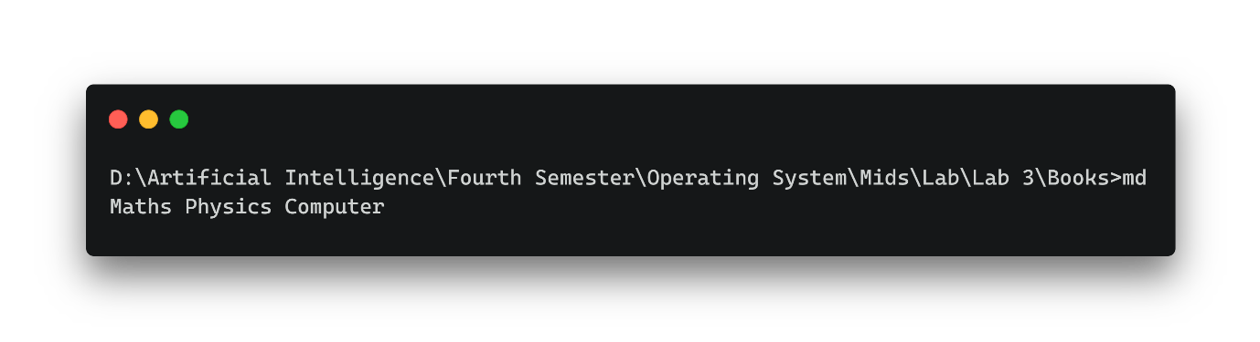
Execution:

Create new folder of any name
Then make subfolder
Then tree command
Hide folder and unhide
Hide specific folder

